# Identity and access smanagement (IAM)

## Creating a user in IAM:

Access your AWS management console and search for IAM.

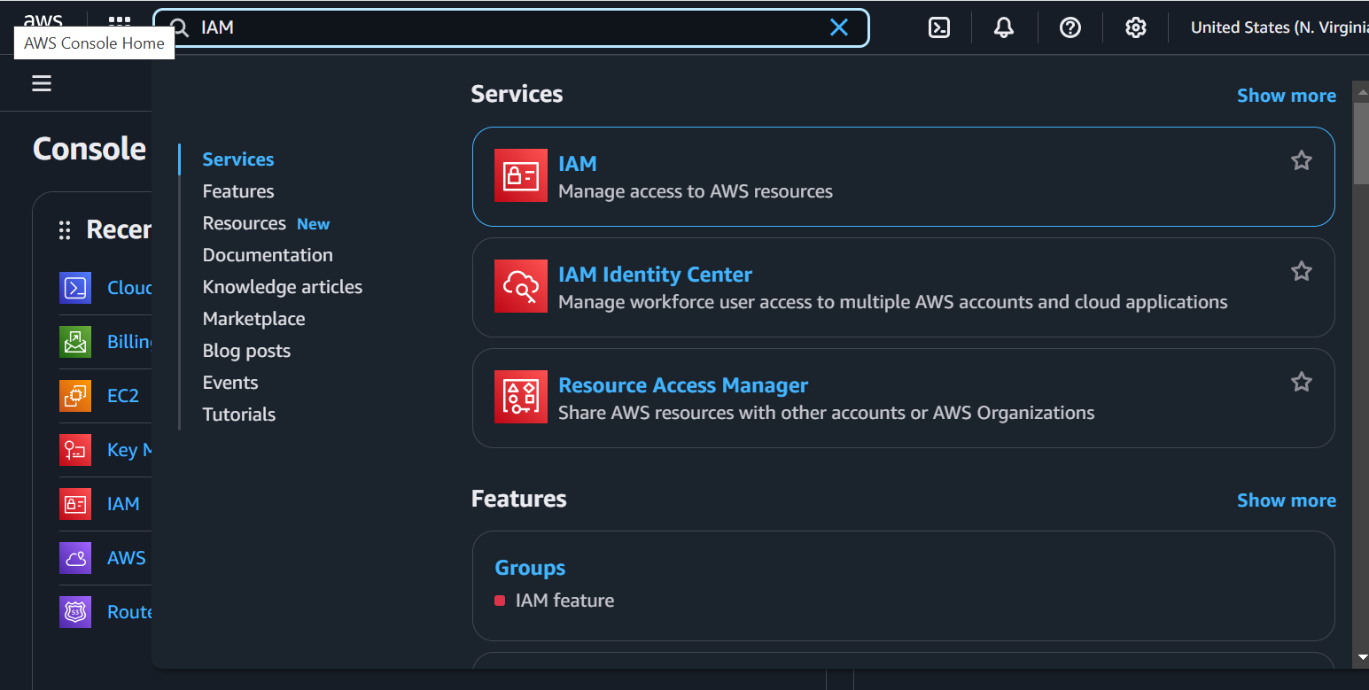

On the next screen, click on Users section.

NOTE: Users in AWS have global scope.

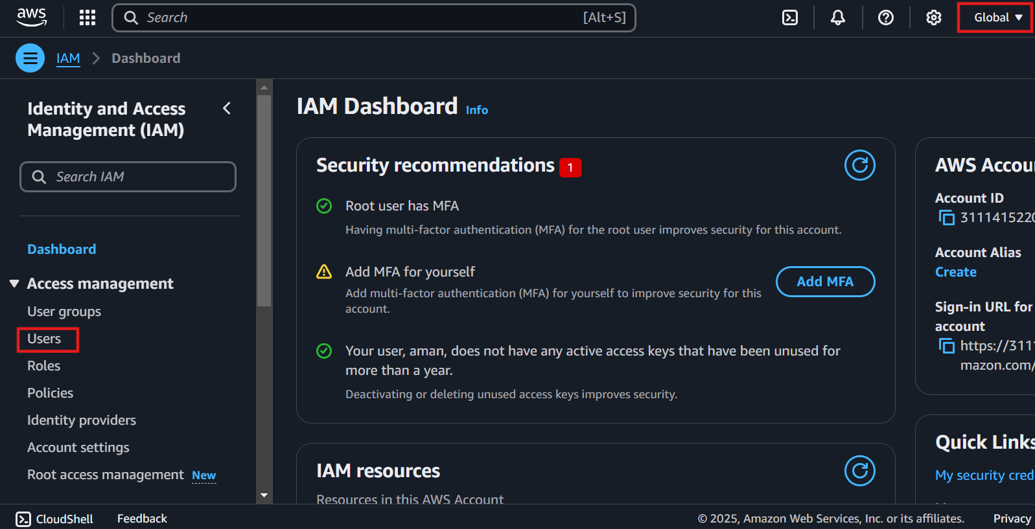

Click on create user button

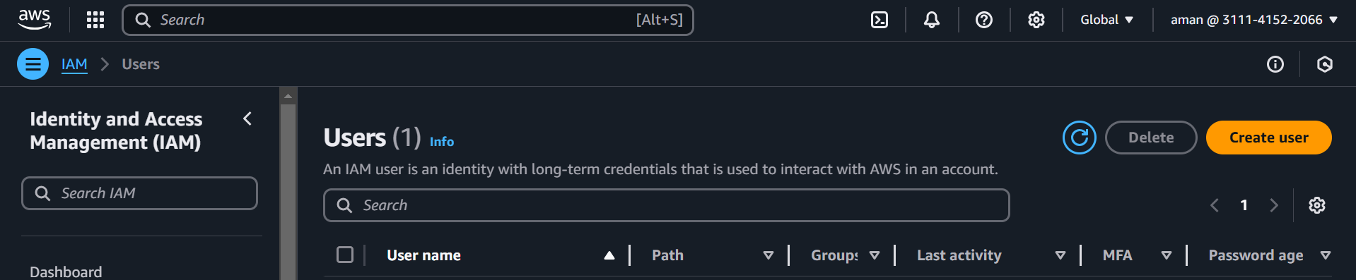

Enter your desired username

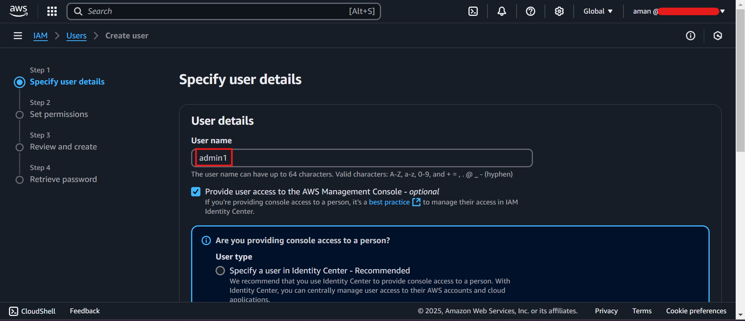

You can provide the custom password and decide whether you want user to change password after first login. Click next,

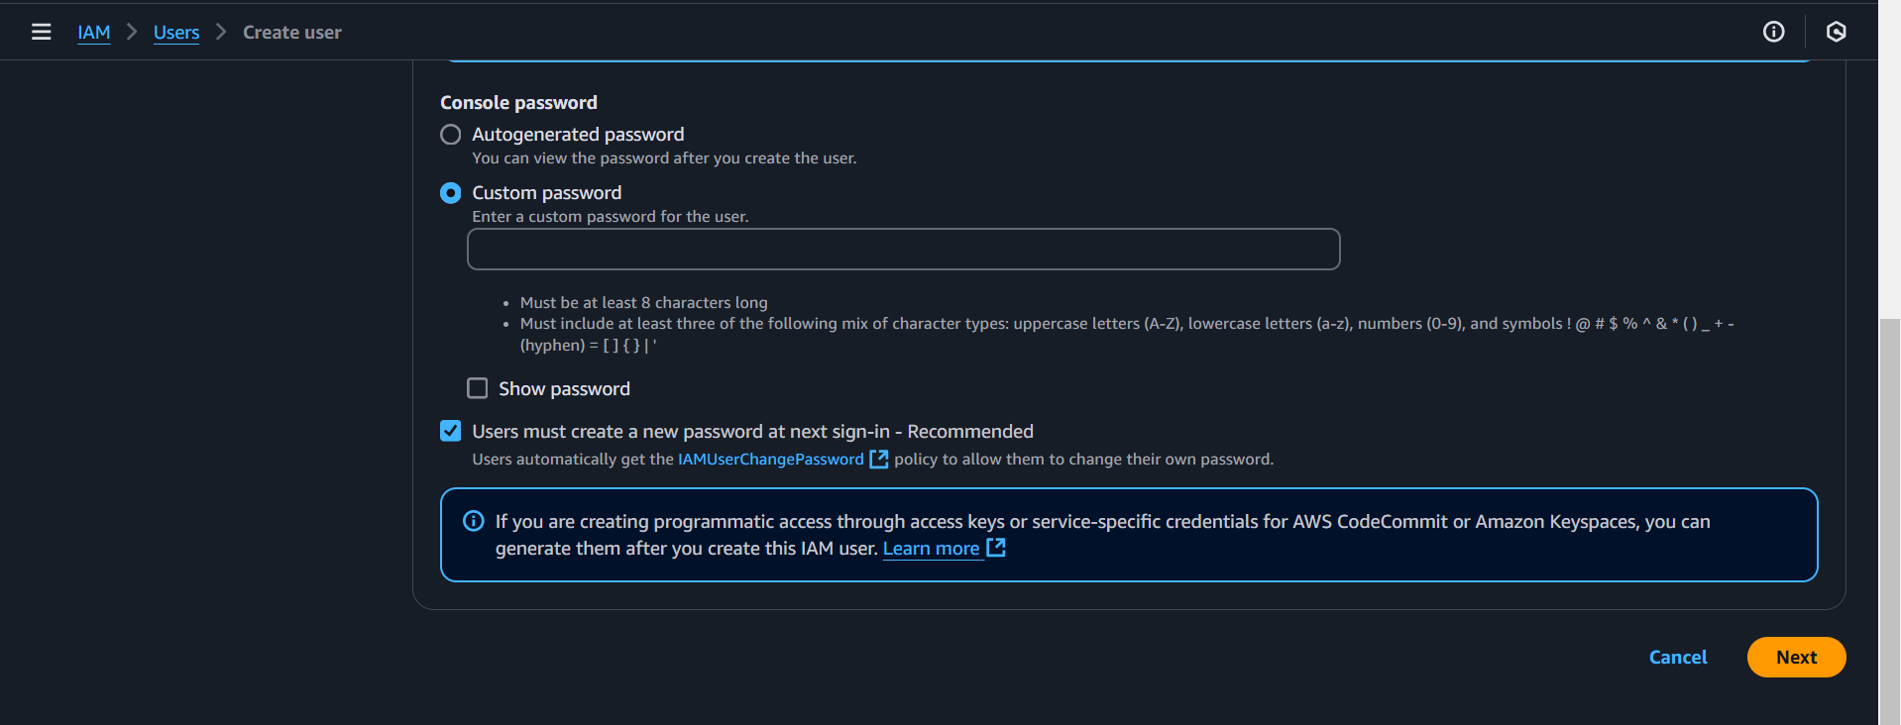

In the below screen you can decide to add user to a group in IAM or assign permissions/policies manually.

If you don’t see a group on your screen in the user groups section, then you can create a group as below:

Click on create group. Choose your desired permission policy and click on create user group.

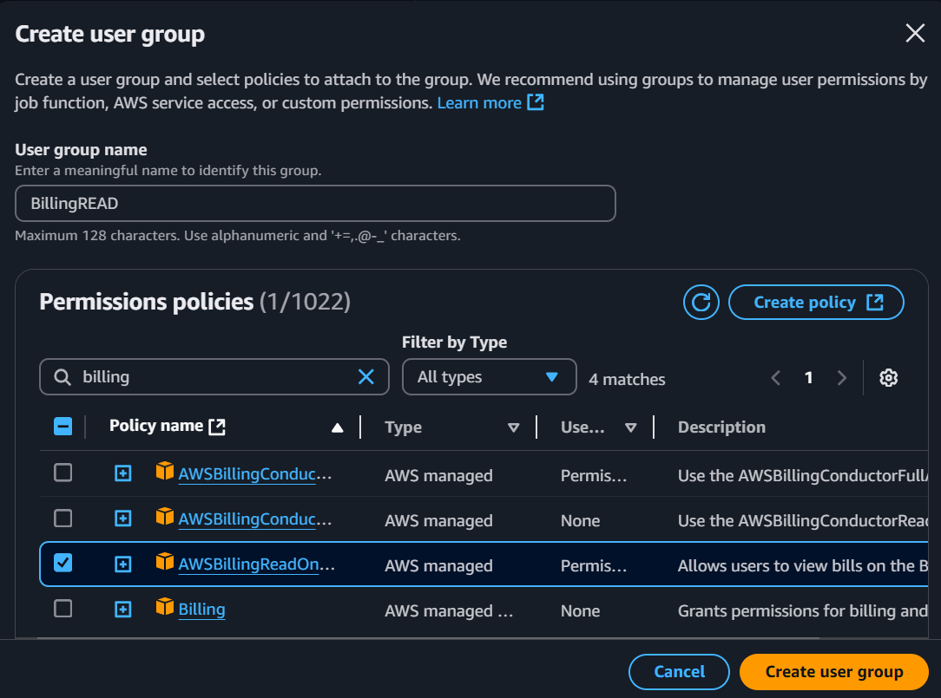

Now choose the group you want your user to be added in and click on Next.

In the next screen you can review the permissions the user will have and add a tag to the user if desired.

The next screen has several options to explore, you can choose to email the sign-in instructions to your desired email address. Or, you can also download a .csv file containing the credentials.

Hit the button *“Return to users list”*

And you can see your user “<username>” is created.

And if you click on your user you will find it belongs to the group of your choice.

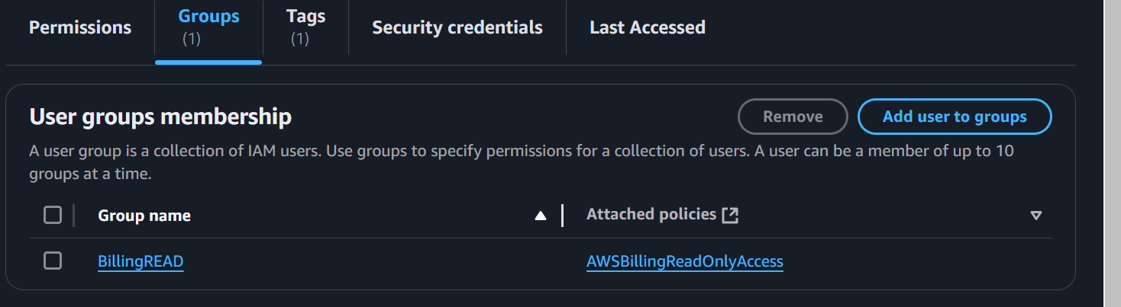

## Policies in IAM:

To view the policies in IAM please click on policies in the IAM screen.

Click on create policy and you will find several options:

If you’re unfamiliar with JSON, don’t panic AWS has a visual way of designing policies. Just pick and choose and AWS will spin its magic wand.

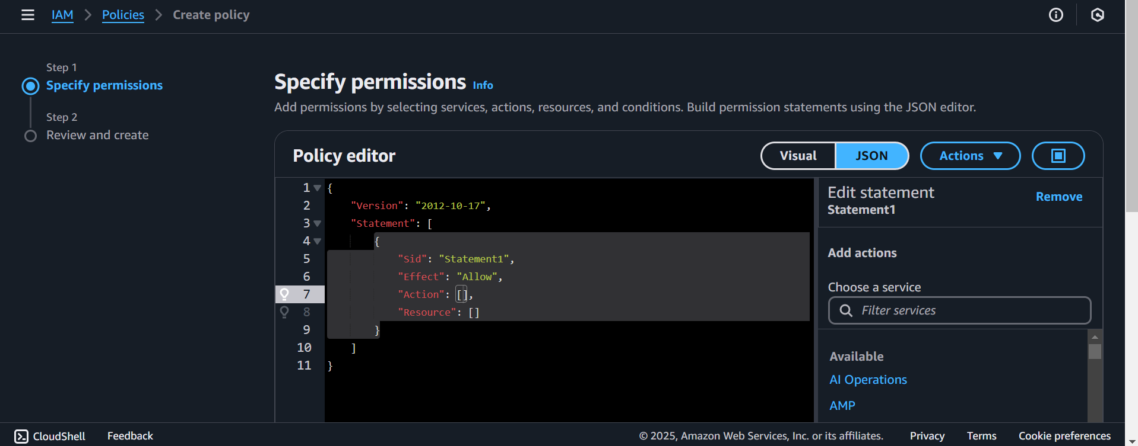

Pick a service and you shall see several options:

An example, here I have picked IAM as the service and the action chosen is all or (*) and I have chosen to deny all actions.

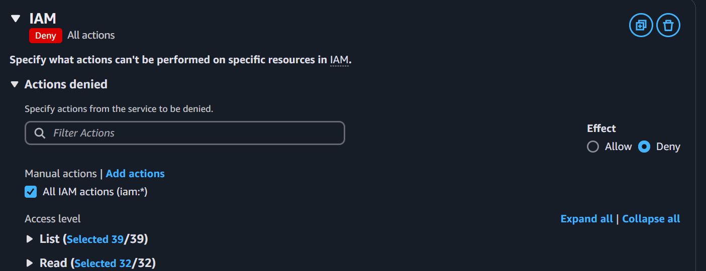

Provide a policy name and click create policy button.

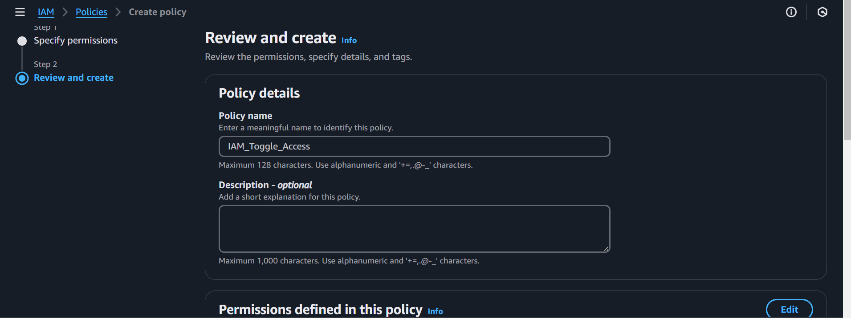

Now let’s see the power of policies.

I am going to add this policy to one of my users and we will see that the user will not be able to access IAM.

Upon logging into my new user account, I will try and access IAM.

And as expected access to IAM is denied for this user.

